**The University of Azad Jammu and Kashmir**



**Name : Nida Hameed**

**Session : 2024-2028**

**Course Title: CA&LD**

**Submitted to : Engr . Sidra Rafique**

**Lab#2**

**NAND Gate:**

**NAND Gate simple circuit:**

**Procedure of NAND gate simple circuit:**

I opened Electronics Workbench and started a new project.

1. I selected the 7400 IC, which has NAND gates in it.
2. I connected Vcc pin 14to power and GND pin 7to ground.
3. I used the first NAND gate by connecting two inputs to pin 1 and pin 2.
4. I took the output from pin 3, which gave me the NAND result.
5. Then I added switches to test the inputs and ran the circuit.
6. The output was correct for all input combinations, just like a NAND gate truth table.
7. The circuit was simple and worked perfectly.

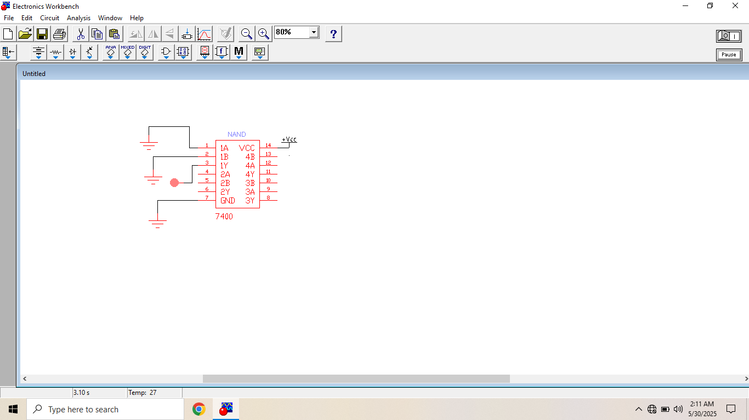

**NAND Gate complicated circuit:**

**Procedure for NAND Gate complicated circuit:**

First, I opened Electronics Workbench and started a new file.

1. I picked the 7408 IC for the AND gate and the 7404 IC for the NOT gate from the component library.
2. Then, I connected Vcc and GND to both ICs (pin 14 to power and pin 7 to ground).
3. I connected two inputs to the AND gate at pins 1A and 1B of the 7408.
4. The output from the AND gate pin 3was connected to the input of the NOT gate pin 1 .
5. I took the final output from pin 2 . This gave me the NAND output.
6. After wiring, I tested the circuit by giving different inputs and checked if the output was correct.
7. It worked like a NAND gate, so the circuit was successful.

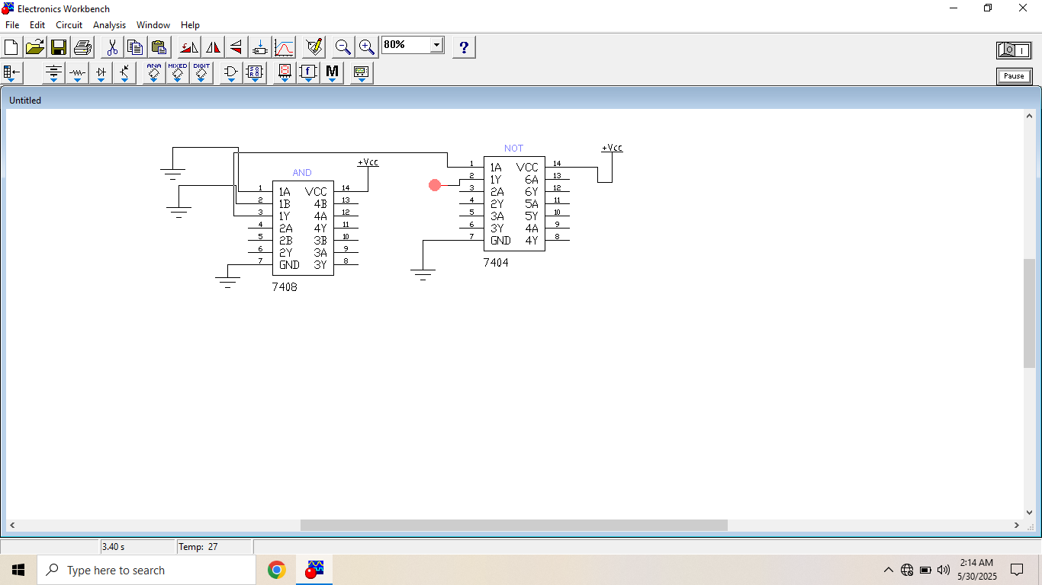

Hardware circuit

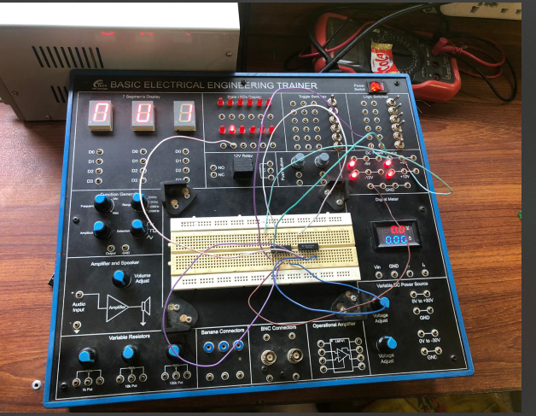

**Table:**

|  |  |  |  |
| --- | --- | --- | --- |
| A | B | A.B | (A . B)’ |
| 1 | 1 | 1 | 0 |
| 1 | 0 | 0 | 1 |
| 0 | 1 | 0 | 1 |
| 0 | 0 | 0 | 1 |

**NOR Gate:**

**NOR Gate simple circuit:**

**Procedure**

1. I opened Electronics Workbench and started a new project.
2. I selected the 7402 IC, which has NOR gates in it.
3. I connected Vcc pin 14 to power and GND pin 7 to ground.
4. I used the first NOR gate by connecting two inputs to pin 1 and pin 2.
5. I took the output from pin 3, which gave me the NOR result.
6. Then I added switches to test the inputs and ran the circuit.
7. The output was correct for all input combinations, just like a NOR gate truth table.
8. The circuit was simple and worked perfectly.

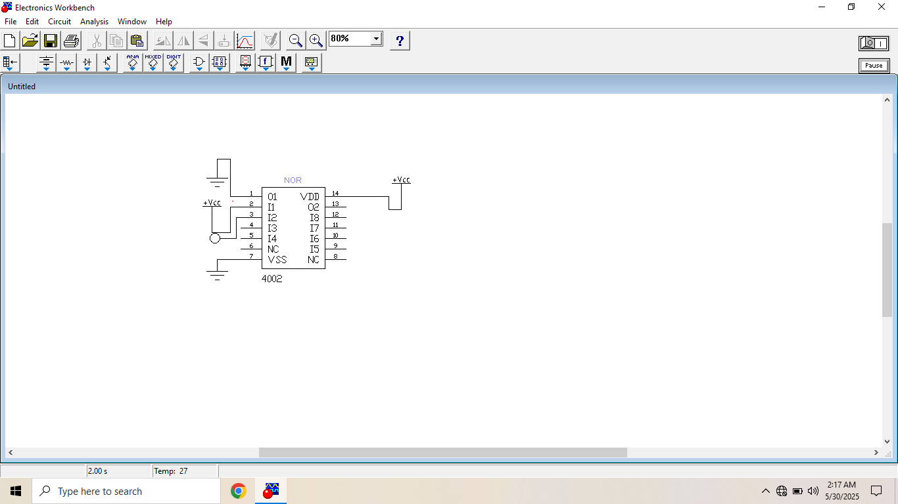

**NOR Gate complicated circuit:**

**Procedure**

I opened Electronics Workbench and created a new project.

1. I selected a basic OR gate and a NOT gate from the components list.
2. I connected two input switches to the inputs of the OR gate.
3. I connected the output of the OR gate directly to the input of the NOT gate.
4. The output of the NOT gate became the final NOR output.
5. I added an LED to the output of the NOT gate to see the result.
6. Then I connected power and ground to all components as needed.

8.The output matched the NOR gate truth table exactly.

9.The circuit worked perfectly and showed how to build a NOR gate from simpler gates.

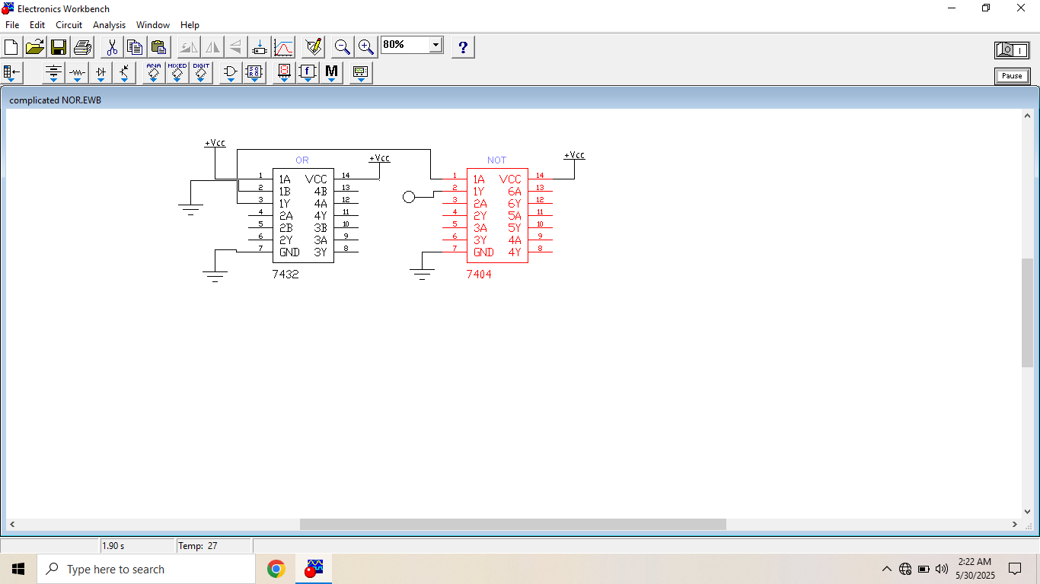

**Table:**

|  |  |  |  |
| --- | --- | --- | --- |
| A | B | A+B | (A+B)’ |
| 1 | 1 | 1 | 0 |
| 1 | 0 | 1 | 0 |
| 0 | 1 | 1 | 0 |
| 0 | 0 | 0 | 1 |